
Hkkjrh; izkS|ksfxdh LkaLFkku iVuk
Indian Institute of Technology Patna
Department of Electrical Engineering
IIT Patna, Campus, Bihta, Patna, Bihar – 801103 Experiment- 6

OPERATIONAL AMPLIFIER APPLICATIONS – II

OBJECTIVE: Designing a Precision Rectifier for a small AC Signal.

COMPONENTS REQUIRED

: Op-Amp : IC : LM 741. 02
: Diode : 1N4148 02
: Resistance : 1 K, 10 K, 100 k . 03Each
: Capacitor : 10 µF. 01

PRECAUTIONS AND GUIDELINES

1. The op-amp (Fig.6.2) generally works on split power supply (e.g. ±12 V). Both positive and negative power supplies must be present whenever op-amp is powered. The range of power supply is from ─15 V to +15 V. Do not forget to connect the common (Ground) terminal of the power supply to the ground on the breadboard.

2. Connecting only one side of power supply or interchanging positive and negative power supplies damages the op-amp.

3. While switching on the set-up, switch on the oscilloscope first, then the power supply to the circuit, and finally the function generator. When switching off, follow the sequence in reverse order.

4. For any IC, never exceed the input voltage beyond the power supply limits.

5. Keep ground terminals of the oscilloscope probes and function generator output, and power supply common connected together throughout the experiment.
The circuit shown in Fig. 6.1 is of precision rectifier for a small ac signal. It consists of two stages:

a) Stage1: Non-inverting amplifier

b) Stage2: Half-wave precision rectifier with gain.

Pre-experiment Reading:

Draw output waveforms with magnitude at points ‘X’ (stage1 o/p) and ‘Y’ (stage2 o/p)

a) With R2 = 10K and

b) Without R2.

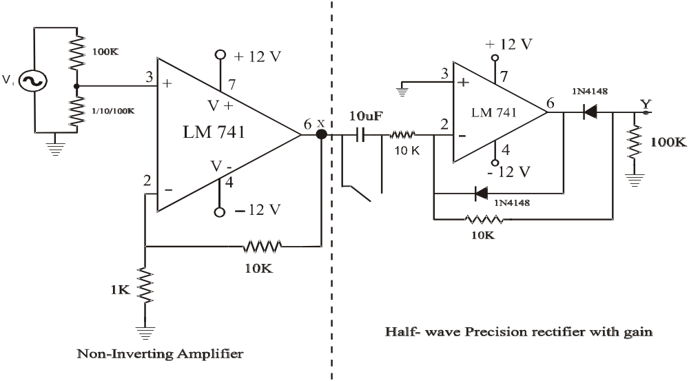 R₁

R₂

Fig.6.1

OBSERVATIONS:

1. Connect the circuit as shown in Fig. 6.1 with R1 = 100 k, and R2 = 1 k . Make sure the power supply ground is connected to the circuit ground.

2. Apply 100 mVp-p, 1 kHz sine wave at Vi from the function generator.

3. Observe the output at point ‘Y’ for

(a) R2 = 1 K (i) With Capacitor C and (ii) without capacitor C (i.e replaced with a short circuit)

(b) R2 = 10 K (i) With Capacitor C and (ii) without capacitor C (i.e replaced with a short circuit)

(c) R2 = 100 K (i) With Capacitor C and (ii) without capacitor C (i.e replaced with a short circuit)

(d) R2 open (disconnected).(i) With Capacitor C and (ii) without capacitor C (i.e replaced with short circuit)

Q1: If the polarities of all the diodes are changed, what will be the waveforms at points ‘X’ and ‘Y’?
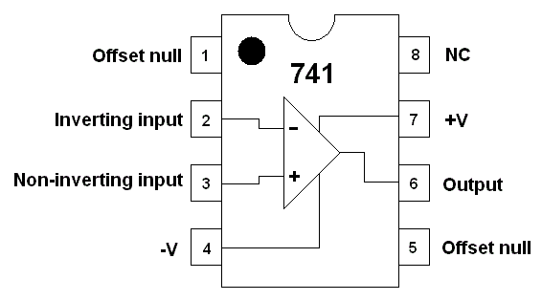

Fig.6.2

